76. Sandboxes and Deployment - 25 July 2022

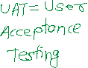

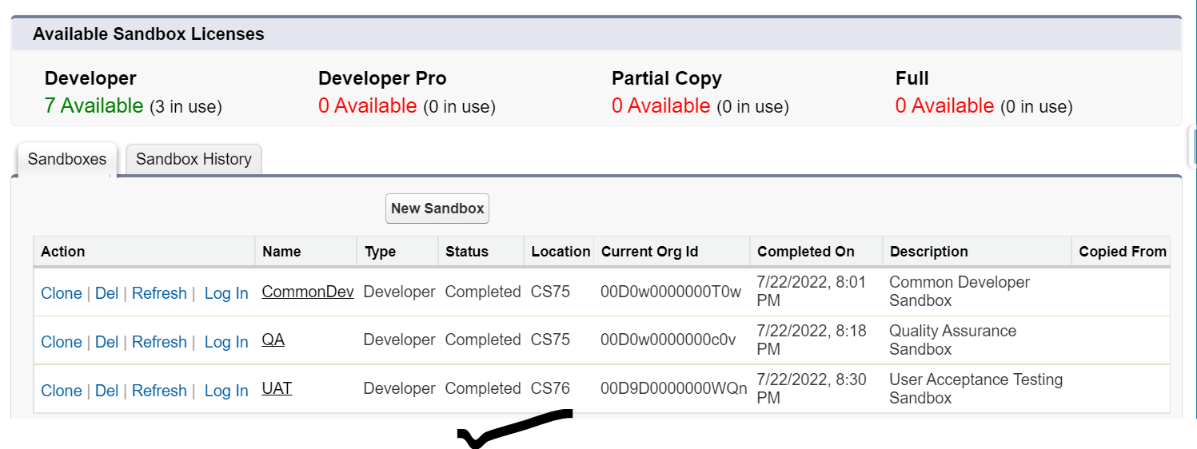

Production Login URL : login.salesforce.com

Sandbox Login URL : test.salesforce.com

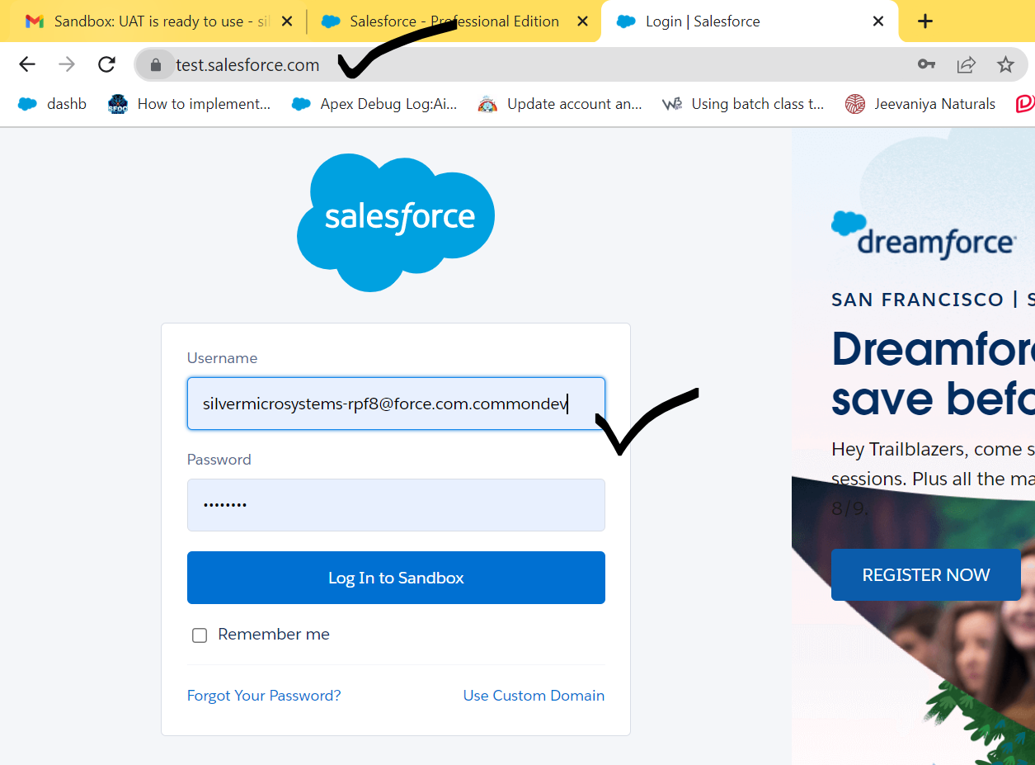

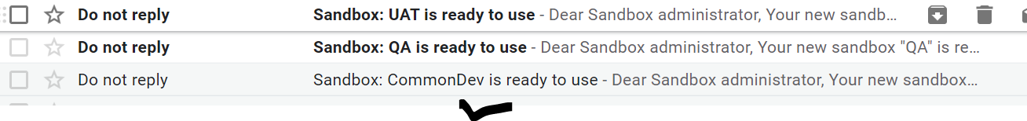

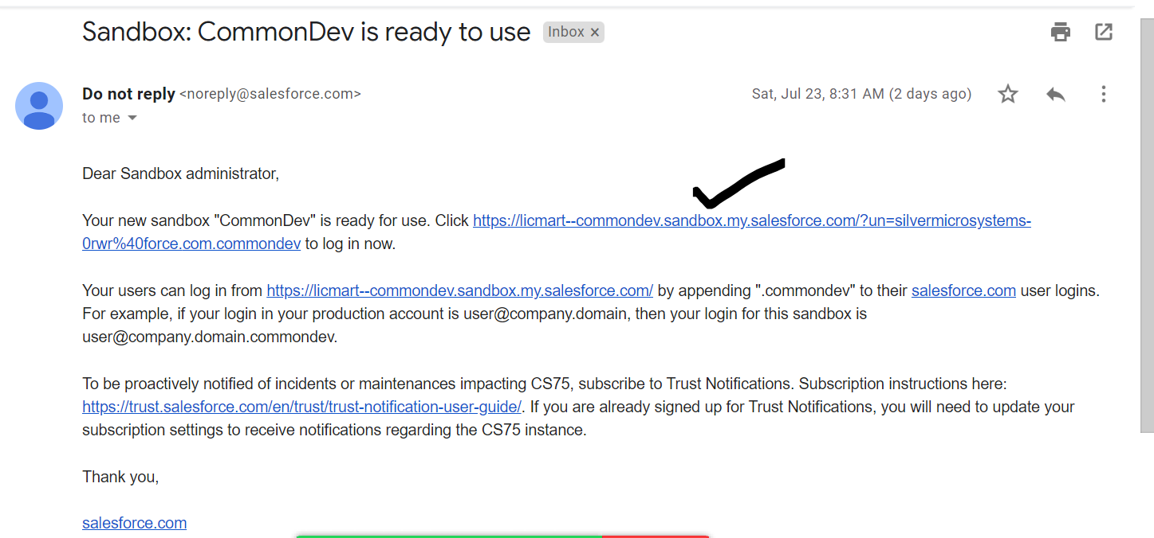

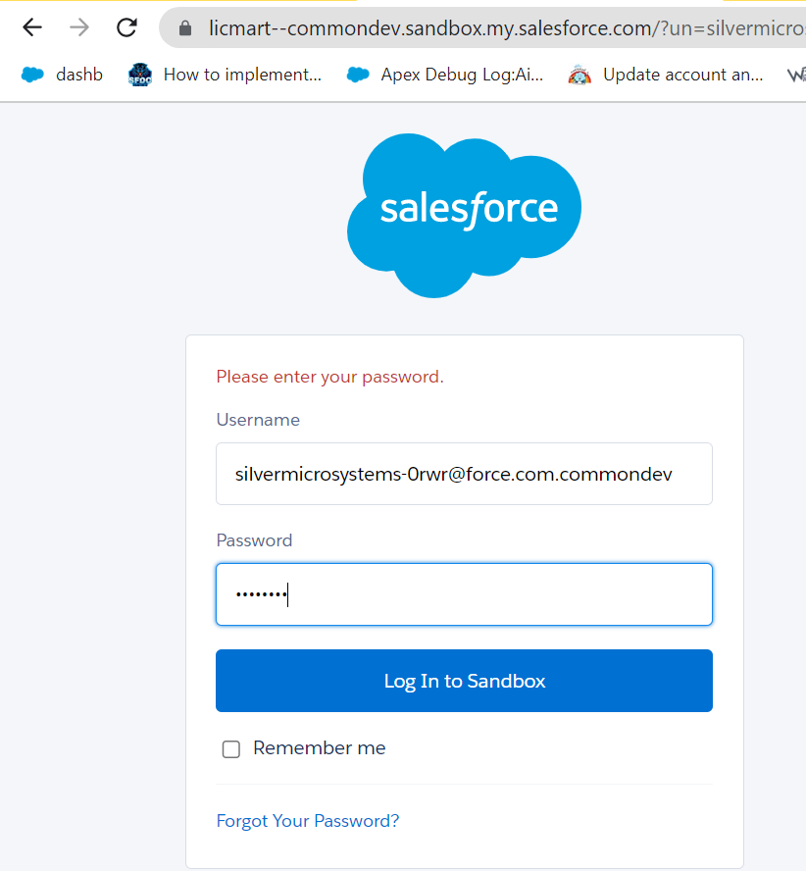

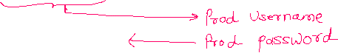

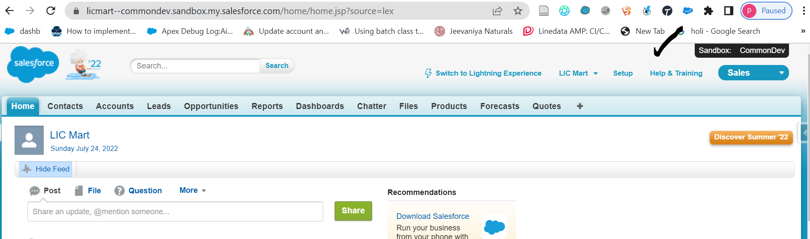

User Story **N-420**:

1] Create an App “LIC Limited”

2] Create an Object “Customer”

3] Create Fields “First Name”, “Last Name”, Pan Card.

4] Create a Tab : “Customers”

5] Prevent InValid Pan Card.

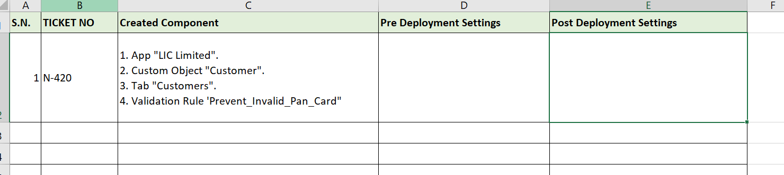



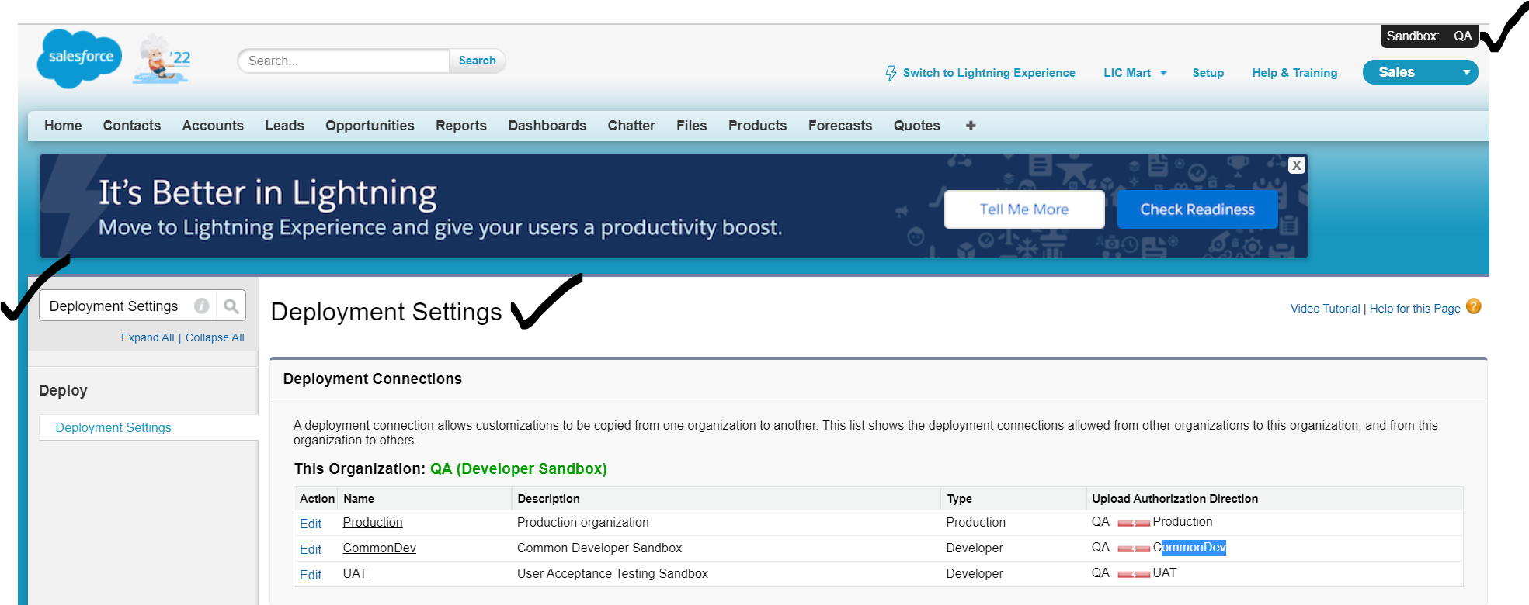

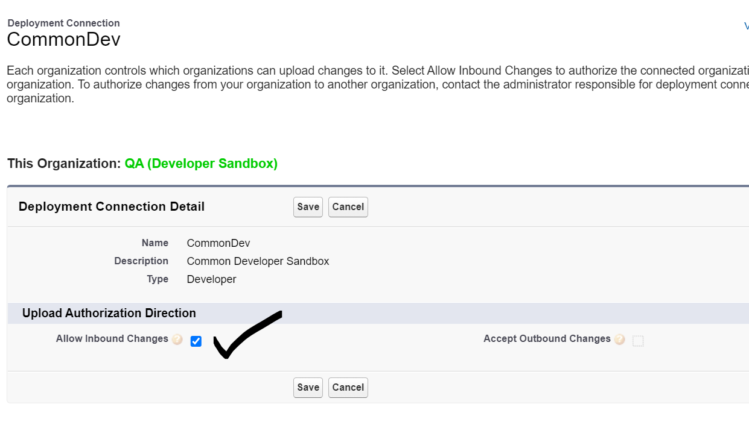

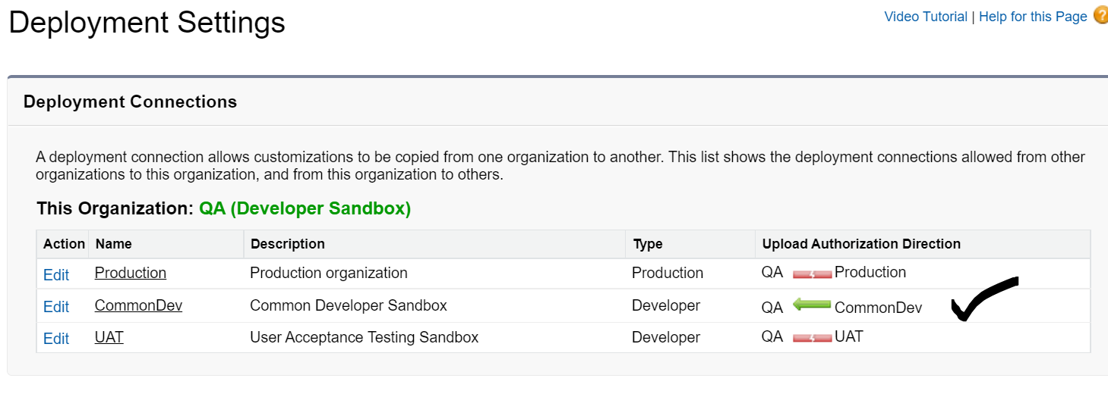

==========================================================================



Deployment Tools

1] ChangeSet (Salesforce Inbuilt)

2] Workbench

3] VS Studio Code

4] ANT Migration Tool

5] Auto Rabbit

1] ChangeSet (Salesforce Inbuilt)

A] Outbound ChangeSet

B] InBound ChangeSet



A] Outbound ChangeSet

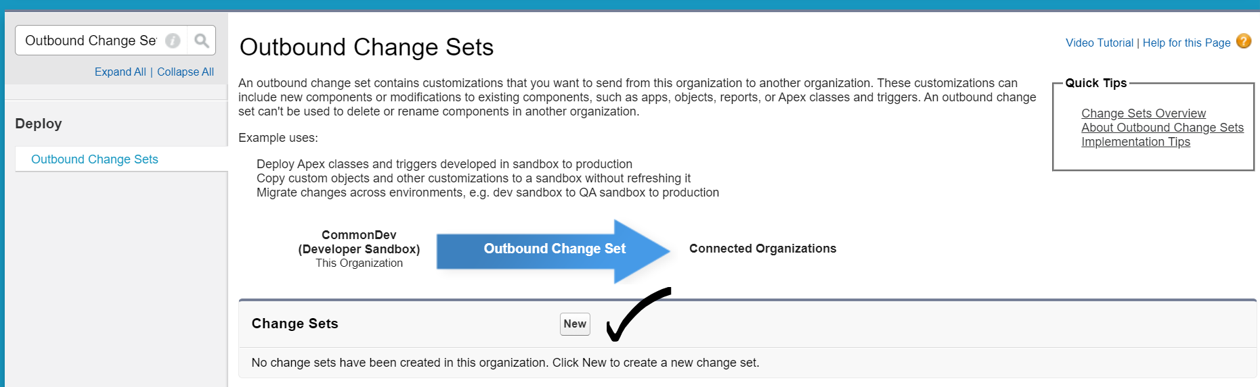

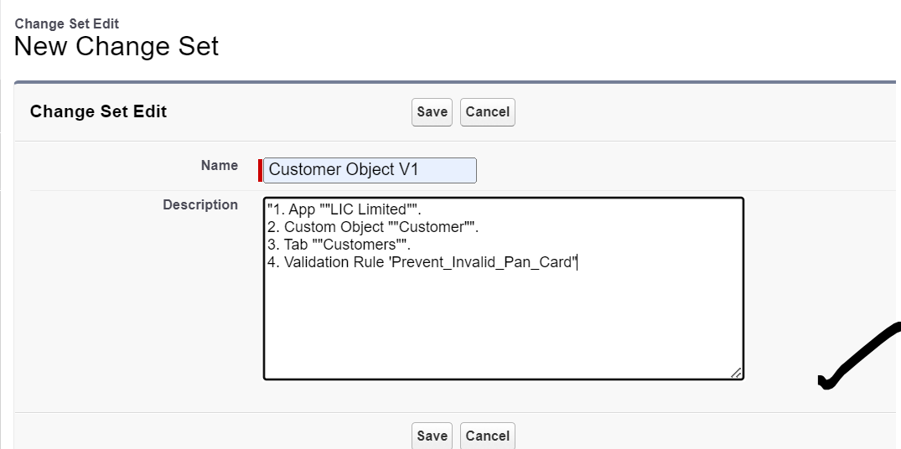

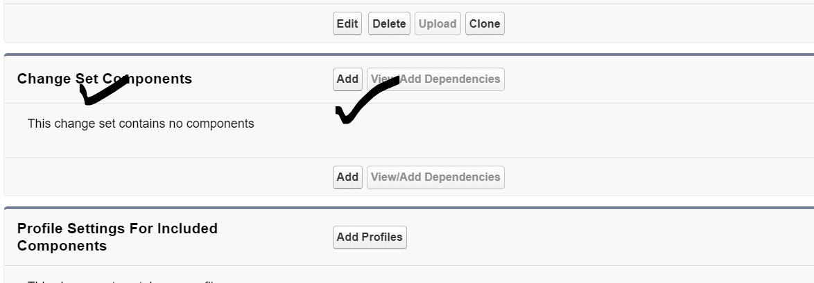

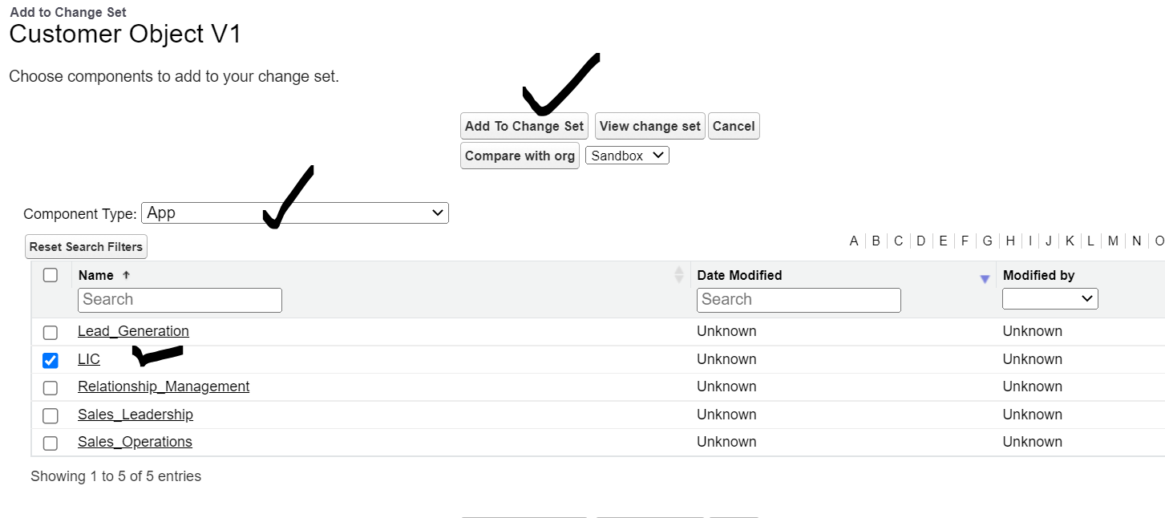

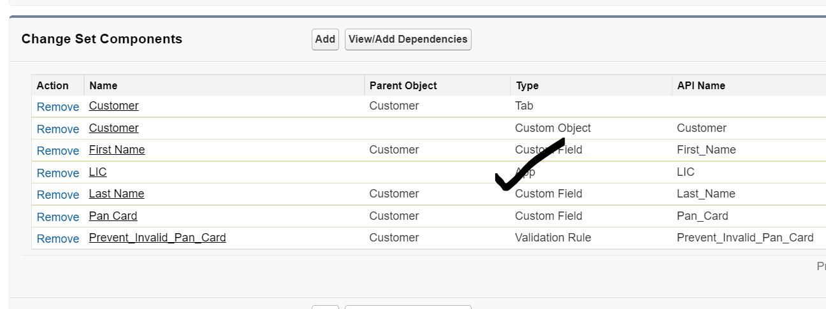

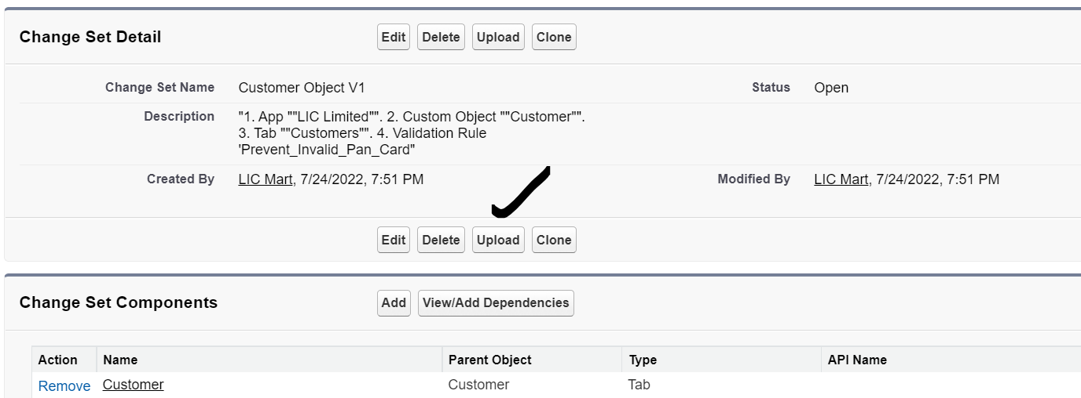

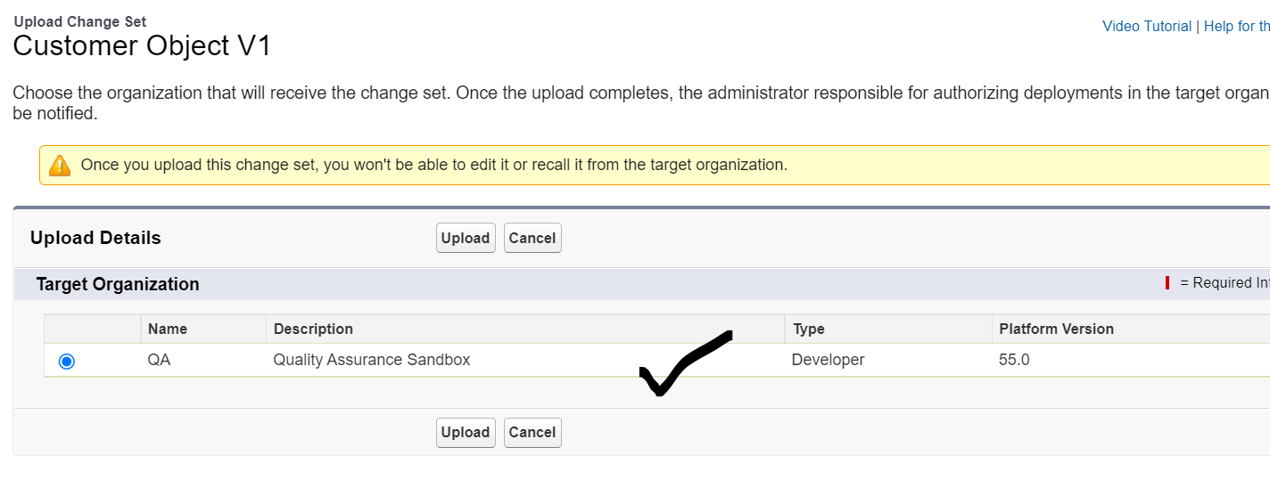

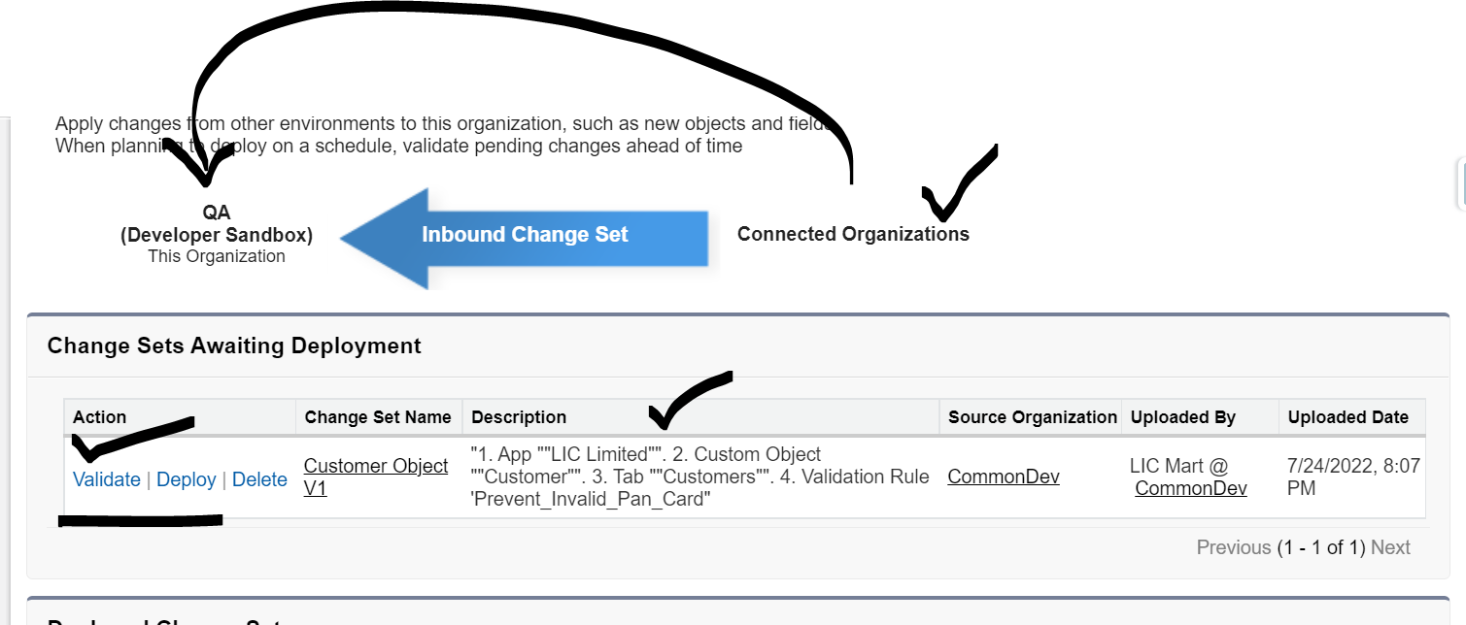

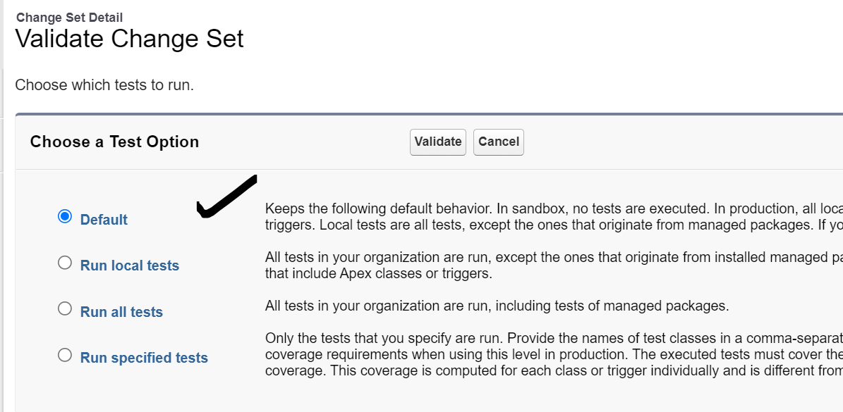

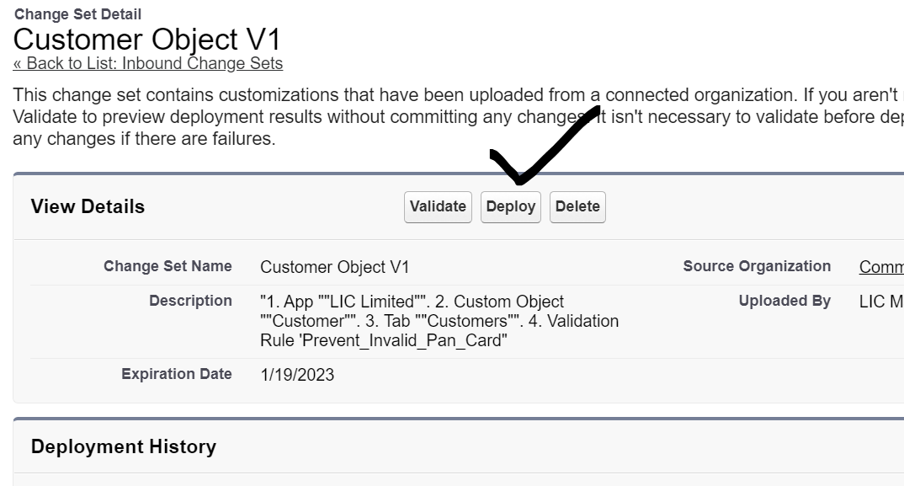

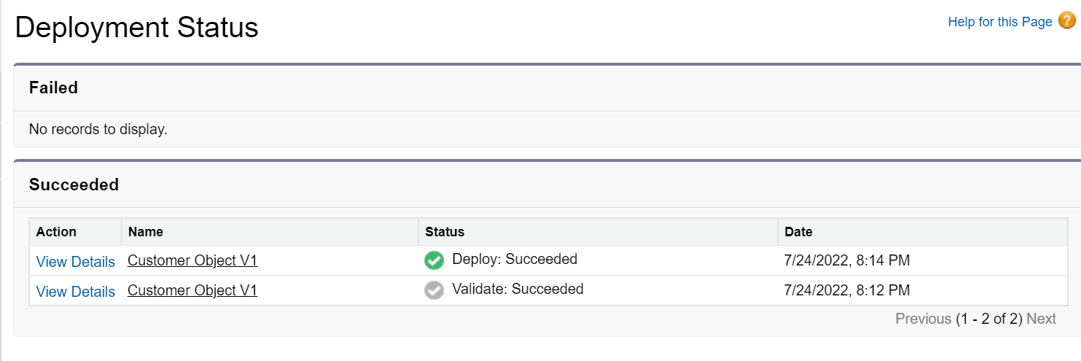

1] Can we deploy records from One Sandbox to another sandbox using ChangeSet.

- No (Use Data Migration Tools)

2] Can we deploy a profile using changeset.

- Yes but, we have to deploy a component with profile.

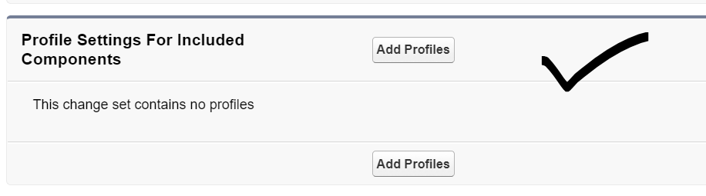

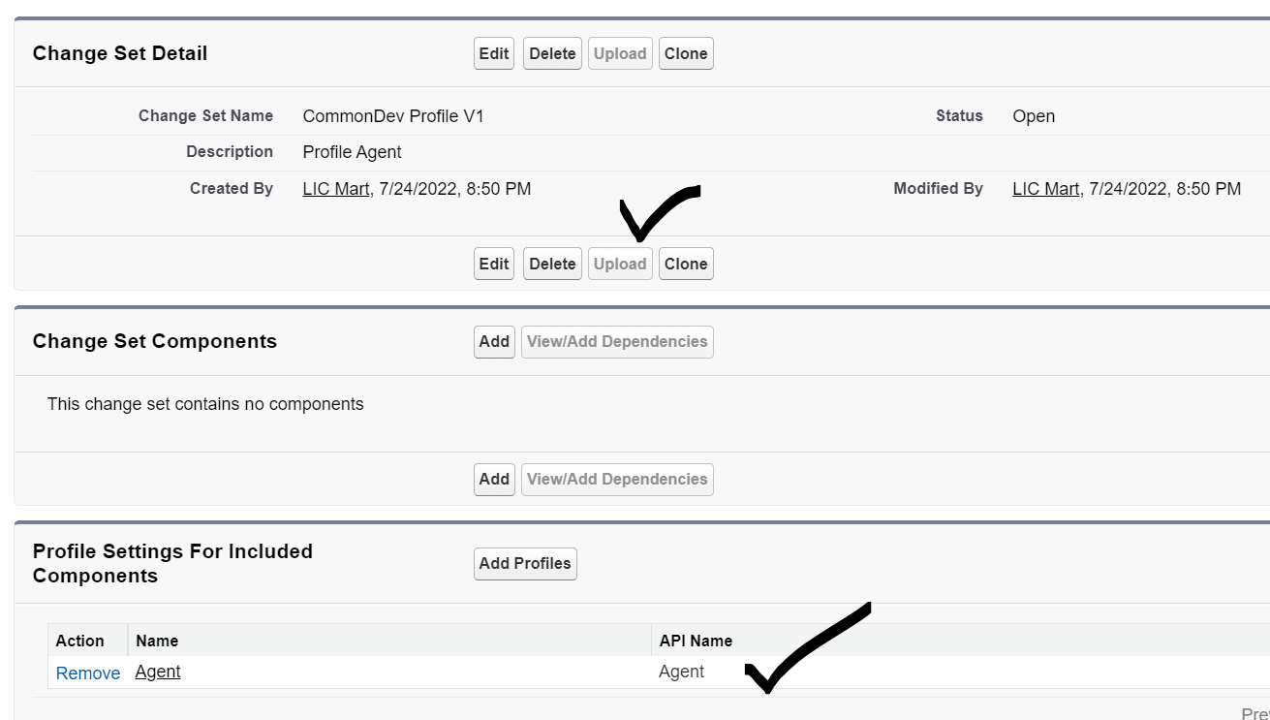

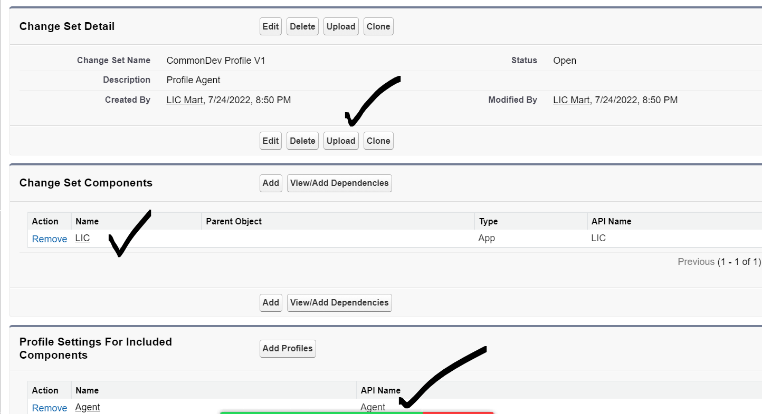

Assignment:

1] App : SBI Bank

2] Object: Applicant

3] Tab : Applicant

4] Fields : First Name, Last Name, Gender, Email ID, Pan Card

5] First Name and Last Name can not create Numbers and Special Symbols.

6] Two User : Munna (Profile : Regional Manager). He can Edit Last Name.

7] Circuit (Profile : Area Operator). He can not edit Last Name.

8] Area Operator can not see Email Id. But Regional Manager can.

9] Pan Card should be mandatory for Regional Manager, but not for Area Operator.

10] Send mail to Applicant Email Id on Applicant creation.